XHIBIT 2
Purging Training Data on the Live System

Project Name : | XHIBIT 2 Project
Status : | Draft
Doc. Ref :
Version : | 0.0A
Issue Date : | 30 September 2003
File Location :

PRINTED COPIES OF THIS DOCUMENT ARE UNCONTROLLED

Electronic Data Systems Ltd
Registered in England Number 53419
Registered Office: 4 Roundwood Avenue, Stockley Park,
Uxbridge, Middlesex UB11 1BQ
Copyright

The copyright in this work is vested in Electronic Data Systems Corporation., and the document is issued in confidence for the purpose only, for which it is supplied. It must not be reproduced in whole or in part or used for tendering or manufacturing purposes except under an agreement or with the consent in writing of Electronic Data Systems Corporation, and then only on the condition that this notice is included in any such reproduction. No information as to the contents or subject matter of this document, or any part thereof, arising directly or indirectly therefrom will be given orally or in writing or communicated in any manner whatsoever to any third party, whether an individual, firm or company, or any employee thereof, without the prior consent in writing of Electronic Data Systems Corporation.
© Copyright 2003 Electronic Data Systems Corporation. All rights reserved

Contact Address

8 Frimley Road
Yorktown House
SURREY
GU15 3BA

Telephone 01276 686200
Fax 01276 415290

Amendment History

Version | Modified By | Date | Approved By (Issue only) | Approval Date | Section, Page(s)and Text Revised  (Add reference to review document if required)
0.0A | Nick Sawyer | 30/09/03

Distribution List
NAME | COPY NO.

Table of Contents

1 XHIBIT Training 4
1.1 Introduction 4
1.2 Purging Training Data 4
1.3 Purging Scripts & Files 4
1.4 Running the Purging Scripts 5

XHIBIT Training

Introduction
Training on the XHIBIT application will be carried out in parallel to the live system, using training terminals in a training suite but there will be no independent training database or application environment. However, training instructors and trainees will log onto the database with distinct database training users and will also use a specific court ID for all training exercises. This will aid in the purging of any data created by the training sessions.
As the core data being used for training is the same data used for the live system, any reference data and data imported from CREST should not be modified during a training session.

Purging Training Data
The purging of any data will be carried out via a combination of database PL/SQL scripts, database procedures and a DOS command file. The command file will be run at the end of each training session to clear out any unwanted training data.
The data purging procedure currently relies on being passed the court ID for the training sessions (Dockford court ID). There is no requirement to pass in the training users at present.

Purging Scripts & Files
There are three scripts/procedures used in the purging of the training data:
xhb_purge_training_data_proc | The predefined database procedure to actually perform the data purge. This is called from the purge_training_data.sql script, passing in the training court ID.
purge_training_data.sql | A PL/SQL script called from within an Oracle SQL*Plus session. This requests the user to enter the training court ID which is then checked against a court ID in a training court database table to ensure that only training court data is purged.
Training_Purge.cmd | The DOS command file run by the training instructor to purge training data.

Running the Purging Scripts
It is the responsibility of the training instructor to perform the task of purging training data created during any training session. This procedure is not automatic and if not carried out after a training session, the database will remain populated with training data for the following session.
At the end of a training session, the instructor should run the Training_Purge command file. The following should appear, the prompt waiting for the training court ID to be entered.
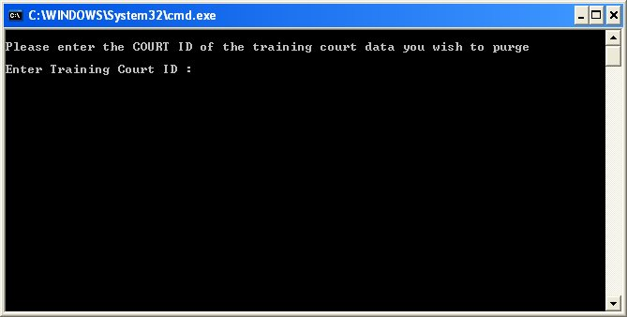

On entering the training court ID, the command file calls the purge_training_data.sql script which checks the ID entered with that stored in the database. If it is valid, the xhb_purge_training_data_proc procedure is called which systematically purges the training data from the live database. If the ID is not valid, no data will be purged.
A log of the results of the data purging is generated which may be viewed to see the outcome. This log file will be name training_data_purge.log. It will not contain a list of what has been deleted, just a message stating either the success or failure of the purge.

